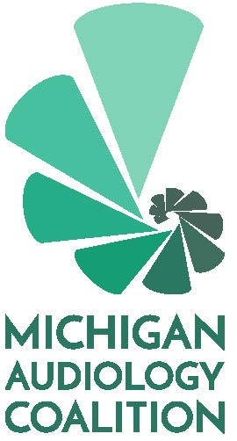

Nomination Form
Please complete and
email to info@michiganaudiologycoalition.org
by April 30, 2021

Name with credentials (as you would like it to appear on the ballot):

Please select the position you are seeking:
President-Elect
Treasurer
Member-at-Large

Please provide a short a bio for members to review at the time of voting. This may include your education, work history and any special skills or interests you feel make you a strong addition to the Michigan Audiology Coalition Board. A short paragraph is sufficient.

Please note that by submitting this form, if you are elected, you agree to attend board meetings on a bi-monthly basis (whether in person or virtually). Historically, these meetings have taken place on the second Friday of the month in the afternoon but are subject to change pending the availability of the board members. New board member orientation is scheduled for June 4th at 1:30pm. The first board meeting for 2021/2022 will be held July 9th at 1 pm.

