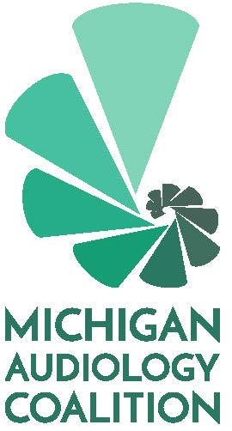

Nomination Form
Please complete and
email to info@michiganaudiologycoalition.org
by April 1, 2020

Name with credentials (as you would like it to appear on the ballot):

Please select the position you are seeking:
President-Elect
Member-at-Large

Please provide a short a bio for members to review at the time of voting. This may include your education, work history and any special skills or interests you feel make you a strong addition to the Michigan Audiology Coalition Board. A short paragraph is sufficient.

Please note that by submitting this form, if you are elected, you agree to attending board meetings on a bi-monthly basis (whether in person or via phone).

